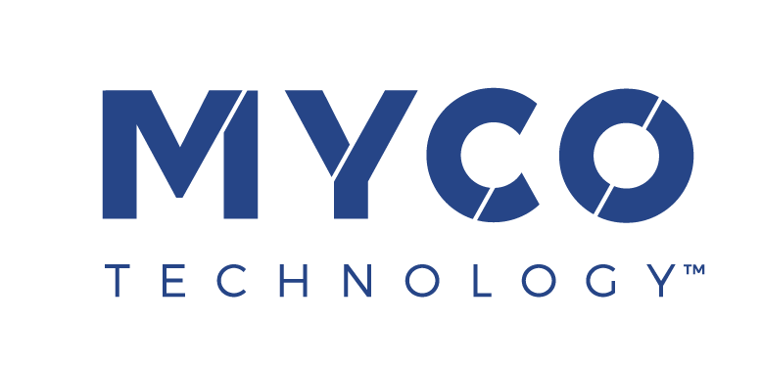

29 June 2022
PRESS RELEASE

MycoTechnology’s mycelial fermentation unlocks
new levels of nutrition in plant proteins, study finds

Transformative FermentIQ™ plant proteins to take center-stage at IFT Expo 2022
Next-generation plant proteins as nutritious as animal proteins are now within reach, thanks to the state-of-the-art, patented mushroom mycelia fermentation platform developed by MycoTechnology, Inc.

In a new scientific study published in the journal Food Science and Technology, MycoTechnology’s FermentIQ™ PTP protein powder – produced by mycelial fermentation of a pea and rice protein blend – was found to deliver significantly better amino acid absorption than the unfermented protein blend. This suggests that MycoTechnology’s protein could be as complete and nutritious as animal proteins – or even more so.

The researchers, based at the University of Illinois and Cornell University, also found that transforming the plant-based proteins with MycoTechnology’s patented fermentation process enabled 99.9% of the protein consumed to be digested. This opens the door to higher quality plant protein products in markets where optimized protein uptake is especially desirable, including the sports, senior, and fortified nutrition sectors. With the digestibility of plant proteins a widely recognized concern, FermentIQ™ PTP protein offers a simple but groundbreaking ingredient solution that heralds a new era for animal free products.

Mushroom mycelia are the invisible, underground root systems of the mushrooms we know and love. MycoTechnology uses this resource as a natural processing agent on a commercial scale. FermentIQ™ proteins offer improved solubility and digestibility because the mycelial fermentation process alters the complex structure of plant proteins. This reduces the presence of anti-nutrients such as phytic acid – molecules that can make it harder for the body to absorb protein.

Showcasing cutting edge plant protein innovation at IFT Expo 2022
FermentIQ™ proteins will take center-stage for MycoTechnology at IFT Expo in Chicago (July 11-13, 2022). Exhibiting at Booth #S3621, the company’s experts will be on hand to discuss the findings of the Illinois/Cornell study and how they translate into the production of plant proteins with transformative benefits.

In addition, the booth will host daily live demonstrations from award winning chef and founder of the Well Beyond Food project Ryan Hutmacher. Chef Ryan, alongside MycoTechnology applications experts, will incorporate FermentIQ™ plant proteins into delicious recipes. Among the dishes available for visitors to sample will be a suite of plant-based meat and dairy concepts that are nearly indistinguishable from the real thing.

Chef Ryan’s culinary creations will provide an opportunity to experience another major benefit of FermentIQ™ plant proteins: improved flavor. The bitter, astringent taste of many plant proteins presents a major challenge for product developers – especially in the protein beverages category. The use of masking agents is often necessary to mitigate unpleasant off-notes, which can compromise clean label strategies.

Equally exciting, early results of product development tests – internally and with customers – suggest that FermentIQ™ proteins may moderate water activity. “We are working to prove this hypothesis,” said CEO Alan Hahn, “as this means our ingredient may help extend shelf life and inhibit mold growth in some food systems, potentially enabling juicer end products and addressing urgent challenges food companies are facing with current inflationary dynamics.”

Hahn added: “Our FermentIQ™ proteins put us in a unique position to study and capitalize on the amazing potential of mushroom fermentation, to unlock value for both manufacturers and their consumers. Our study of how we can fully harness the power of our natural fermentation platform has only just begun. As the world’s leading explorer of mushroom mycelia, we continue our forage to discover - and bring to life - the wonders of mycelia to create better foods, and a better future.”

Visit MycoTechnology on Booth #S3621 at IFT Expo, which takes place 11-13 July 2022 at McCormick Place, Chicago IL.

ENDS

For more information contact:
Richard Clarke, Ingredient Communications
Tel: +44 (0)7766 256176 | Email: richard@ingredientcommunications.com

About MycoTechnology, Inc.
Established in 2013 and based in Aurora, Colorado, MycoTechnology creates products from mushroom mycelia that solve the biggest challenges in the food industry. The world’s leading explorer of mycelia, MycoTechnology is dedicated to increasing the availability of healthy, sustainable, clean label and high-quality food options through natural mushroom fermentation. Its product portfolio includes ClearIQ™ flavor, a line of transformative mushroom-derived flavor modulation tools that decrease the perception of bitter and off-notes, enable the formulation of products with higher nutrient density, and reduce salt and sugar across a broad spectrum of applications. MycoTechnology also offers FermentIQ™ protein, a line of plant protein products produced via a proprietary fermentation process that harnesses the power of mushroom mycelia to make plant proteins that are more functional, easier to digest, and more delicious. MycoTechnology is a team of near 100 employee-shareholders and continues to recruit additional colleagues to aid expansion and growth.

Clark et al. Shiitake mycelium fermentation improves, digestibility, nutritional value, flavor and functionality of plant-based proteins, LWT – Food Science and Technology, 156 (2022) 113065 In collaboration with University of Illinois Department of Animal Sciences and Cornell University, Department of Food Sciences

